Sales Performance Dashboard using Microsoft Excel

Project Overview:
Developed an interactive Excel Sales Dashboard to analyze sales performance across regions, countries, product categories, and years using Pivot Tables, Pivot Charts, Slicers, and KPI metrics. The dashboard enables business users to monitor revenue trends and identify top-performing markets.

Dataset Description:
Attribute | Value
Dataset Size | 1000 Sales Records
Years Covered | 2010–2016
Regions | 6
Countries | 10
Product Categories | 10
Metrics | Revenue, Cost, Profit, Units Sold

3)Tools Used:
- Microsoft Excel
- Pivot Tables
- Pivot Charts
- Slicers
- Conditional Formatting
- Data Cleaning
- SUMIFS
- COUNTIFS
- Calculated Fields
- Dashboard Design

4) Dashboard Components Detailed Analysis:
1) Revenue by Year:
Purpose: Shows the yearly sales revenue from 2010-2016
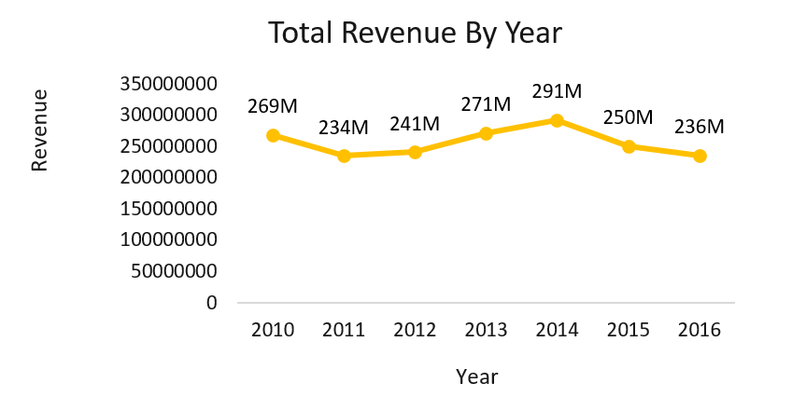
Analysis:
- Revenue increased steadily from 2011 to 2014.
- 2014 was the best-performing year.
- Revenue dropped after 2014.
- 2011 and 2016 are the weakest years.
Business Insights:
- Investigate what strategies were us in 2014.
- Compare 2015-2016 with 2014 to understand the decline

2) Revenue by Region and Year:
Purpose: Shows yearly revenue generated by each region.
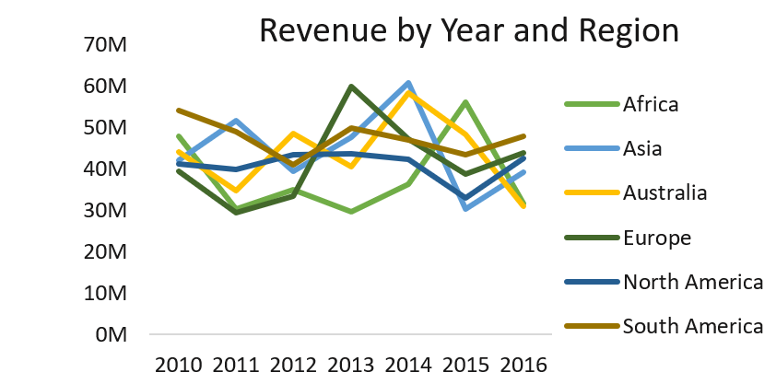
Analysis:
- South America consistently contributes high revenue.
- Asia and Australia also perform strongly.
- Revenue distribution is fairly balanced across regions.
Business Insights:
- Regional growth analysis.
- Comparing yearly performance.
- Identifying which region drives revenue each year.

3) Revenue and Cost by Region:
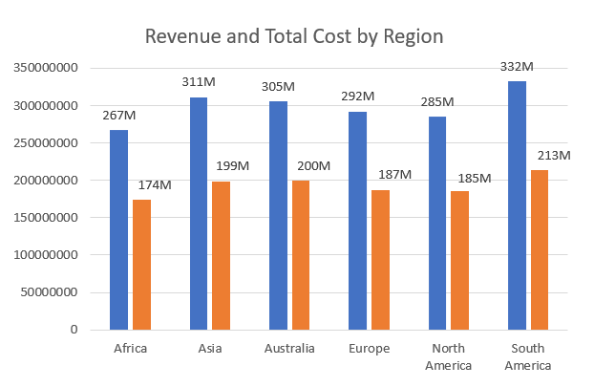Blue = Revenue (M) Orange =Cost (M)

Total
Revenue = 1.792 B
Cost = 1.158 B
Approximate Profit = 633.68 M

Analysis:
- Highest Revenue: South America
- Lowest Revenue: Africa
- Cost follows revenue closely.
Business Insights:
- Africa has growth potential.

4. Revenue by Order Priority:

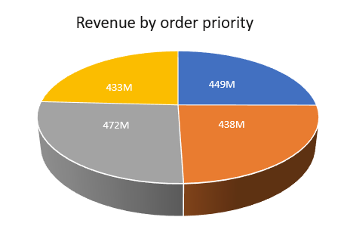
Analysis:
Highest Revenue:
- Low Priority Orders
Lowest Revenue:
- Medium Priority Orders
Business Insight:
- Low-priority orders generate the largest share of sales.
- Critical orders also contribute significantly.

5. Revenue by Countries:
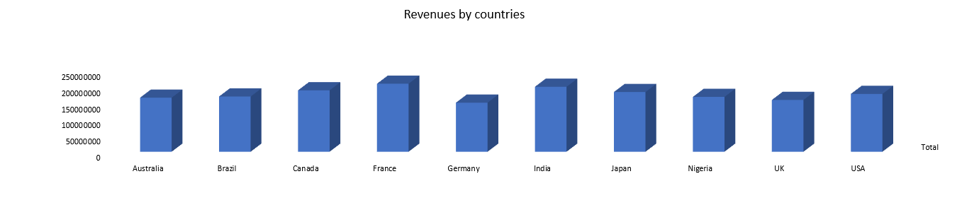

Analysis:
Highest Revenue:
- France
Lowest Revenue:
- Germany
Business Insight:
- France and India are major markets.
- Germany may need better marketing or expansion strategies.
6. Revenue by Items:
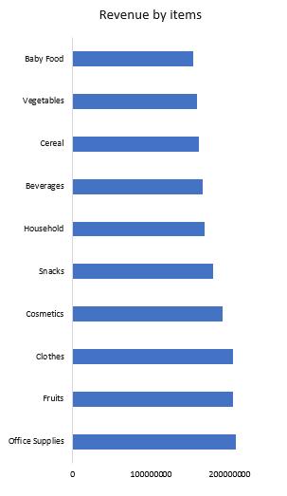

Analysis:
Highest Revenue:
- Office Supplies
Lowest Revenue:
- Baby Food
Business Insight:
- Office Supplies, Fruits, and Clothes are the best-selling categories.
- Baby Food contributes the least revenue.

5) Overall Dashboard Summary:
- Total Revenue: ~1.792 Billion
- Total Cost: ~ 1.158 Billion
- Estimated Total Profit: ~ 633.68 Million
- Best Year: 2014
- Top Region: South America
- Top Country: France
- Best-Selling Item: Office Supplies
- Highest Revenue Order Priority: Low Priority (L)

6) Business Recommendations
- Expand operations in high-performing regions.
- Investigate the post-2014 revenue decline.
- Improve marketing in lower-performing regions.
- Increase inventory for top-selling product categories.
- Monitor costs to improve profit margins

7) Conclusion:
The Excel Sales Analysis Dashboard provides clear insights into sales performance, trends, and customer purchasing patterns. It helps businesses make data-driven decisions, identify growth opportunities, and improve overall sales performance.

